City of Otsego
13400 90th Street NE
Otsego, MN 55330

Waiver
In consideration of my enrollment in this program sponsored by the Otsego Parks and Recreation Department, I certify that I have disclosed to the Otsego Parks and Recreation Department any restrictions or conditions that may hinder my participation in this program. By agreeing to this waiver, I also give my permission for myself to participate in all activities associated with this program, including those activities requiring transportation.

Furthermore, I herby release, discharge, and hold harmless the City of Otsego, its employees, co-sponsors, partner agencies, volunteers, instructors, and contractors from all actions, claims, demands, and costs for any injury or illness that I may suffer as a result of my participation in this program and associated activities.

Furthermore, unless stated in writing, I give permission to use any photographs or videos taken during the program or activity by staff members for public relations purposes by the Otsego Parks and Recreation Department, its co-sponsors, and partner agencies with the understanding that all personal information will be withheld from the public view.

I have read and understand the above:
Print Name, Give Signature & Date
1.________________________________ 2. _______________________________________
__________________________________ _______________________________________
3. ________________________________ 4. _______________________________________
__________________________________ _________________________________________
5. ________________________________ 6. _______________________________________
__________________________________ _________________________________________
7. ________________________________ 8. _______________________________________
__________________________________ _________________________________________
9. ________________________________ 10. ______________________________________
__________________________________ _________________________________________
11. _______________________________ 12. ______________________________________
__________________________________ _________________________________________
- Each team roster must consist of a maximum of 12 players.
- This form is due to be turned in the first night January 14.

Otsego Parks and Recreation Contact Information:
League Contacts: Amy Rancourt & Stacy Carlson @ recstaff@ci.otsego.mn.us
Recreation Coordinator: Connie Schwecke @ recreation@ci.otsego.mn.us
Parks and Recreation Office Phone: 763-235-3148
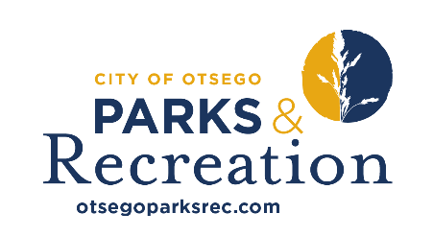 TEAM ROSTER

TEAM NAME:
CAPTAIN’S NAME:

1. | Name: |  | Phone:
 | Email Address:
2 | Name: |  | Phone:
 | Email Address:
3 | Name: |  | Phone:
 | Email Address:
4 | Name: |  | Phone:
 | Email Address:
5. | Name: |  | Phone:
 | Email Address:
6. | Name: |  | Phone:
 | Email Address:
7. | Name: |  | Phone:
 | Email Address:
8. | Name: |  | Phone:
 | Email Address:
9. | Name: |  | Phone:
 | Email Address:
10. | Name: |  | Phone:
 | Email Address:
11. | Name: |  | Phone:
 | Email Address:
12. | Name: |  | Phone:
 | Email Address:

